|  |
| --- |
| University of Suffolk |
| Game Design Document |
| Group 6 |

|  |
| --- |
| By Jack E. Massey S189328 |

Content:

Page 1: - Narrative

Synopsis

Full Story

Page 2: - Characters

Main Character

God of Nature

The Mother

Page 3: - Assets

Page 4: - Level Design

Page 5: - Gameplay

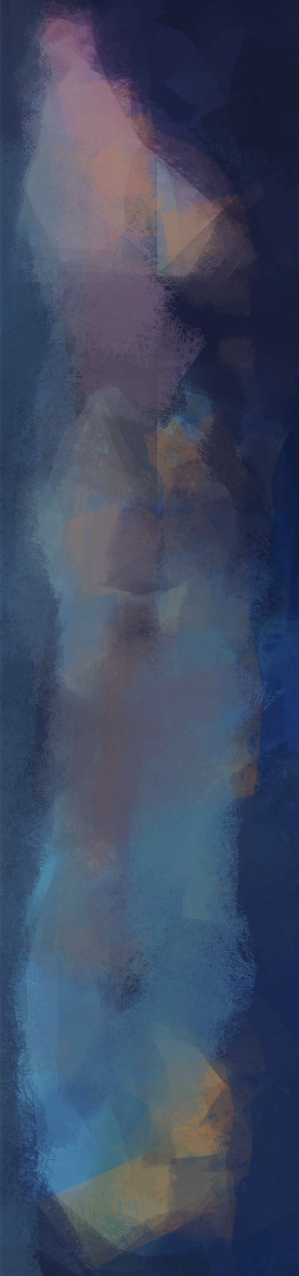

Narrative: -

# Synopsis:

In a mysterious land, a small creature called Ciwtylluan has fallen out of his nest causing him  
to fall into a cave hidden deep below the Jungle where he lives. Seeing his situation, a God of  
Nature comes to help him return to his nest. But they have a long journey, through the dark  
depths of the Cave, the fiery inferno of the Dead place, and the savagery of the Jungle.

# Full story:

In a jungle, a young creature called Ciwtylluan, rests in his nest. Suddenly, a tremor causes Ciwtylluan to fall from his nest into a cavern far below. A god of nature seeing the creature’s predicament, decides to help him return to his nest.

Ciwtylluan seeing there is no way to return home from the way came follows a breeze that   
indicates that there may be another way out.  
The God of Nature begins to guide Ciwtylluan creature through the cave, helping him to   
avoid perilous falls and some dangerous creatures lurking in the shadows.  
Eventually Ciwtylluan finds the exit to the cave and goes through it. On the other side reveals   
the dead place. A hell pit full of fire and significantly more deadly dangers than there were experienced in the previous area.

The god of nature seeing that this isn’t any better than the place before and decides to   
continue to help Ciwtylluan traverses through the dead place. After getting through the   
harsh dangers of the dead lands, Ciwtylluan reaches the edge of the jungle where he lives.

But the god of nature knows the dangers of the Jungle and so continues to help Ciwtylluan   
traverse the jungle to reach his nest.  
It turns out that jungle has far more numerous and dangers than there were in both the Cave  
 and the dead lands combined.  
Eventually passing through the many challenges that awaited ahead of Ciwtylluan.   
He eventually reaches his home and enters his nest where his mum is looking for him in   
distress. Seeing he has returned help him into the nest. The game ends with camera panning   
out. But as the screen fades to black, a sound of distress can be heard.

-This is From the Narrative Design File.

Characters: -



# The Main Character:

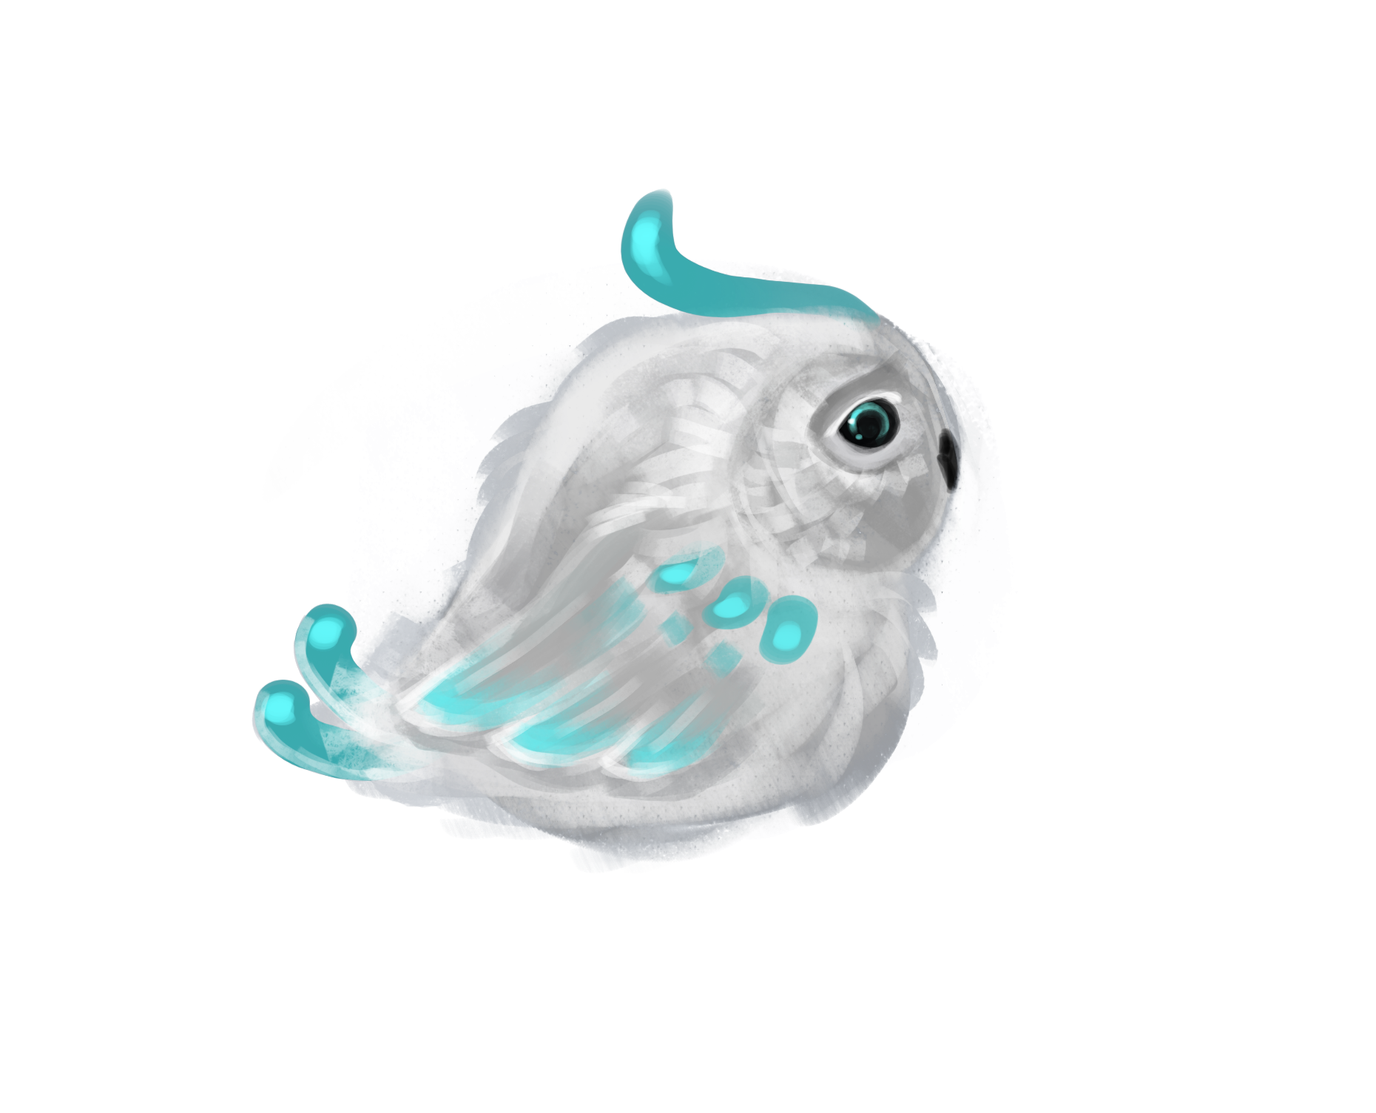

The main character, is called Ciwtylluan and is designed to look like a Juvenile owl.  
With his cute design players will definitely feel more empathy for as he looks innocent.  
With his design he will also stand out of all the backgrounds as because of his white and turquoise colouring.

The Main Character’s design by Marta

He may also have a growth which would indicate that he is dying, because he was infected by   
some mysterious and deadly fungus/disease.

The name Ciwtylluan is welsh and come from the words Ciwt and Tylluan, meaning Cute Owl.



# God of Nature:

This is the character that the player takes control of. It’ll be represented in the game by the mouse cursor when playing.

The character will be very empathetic and will want to help the Ciwtylluan return to his mother. Overall this character is a blank   
  
slate, so really the god of nature is the player.

The current God’s Hand asset by Eva

# The Mother:

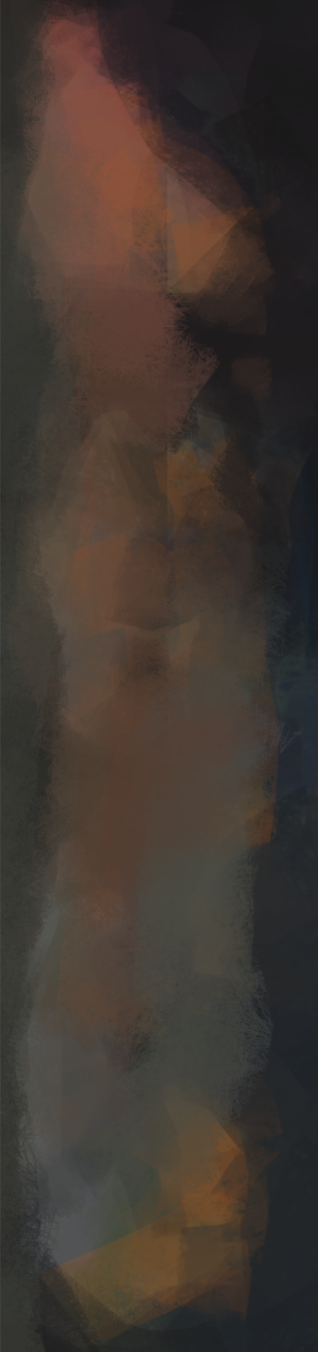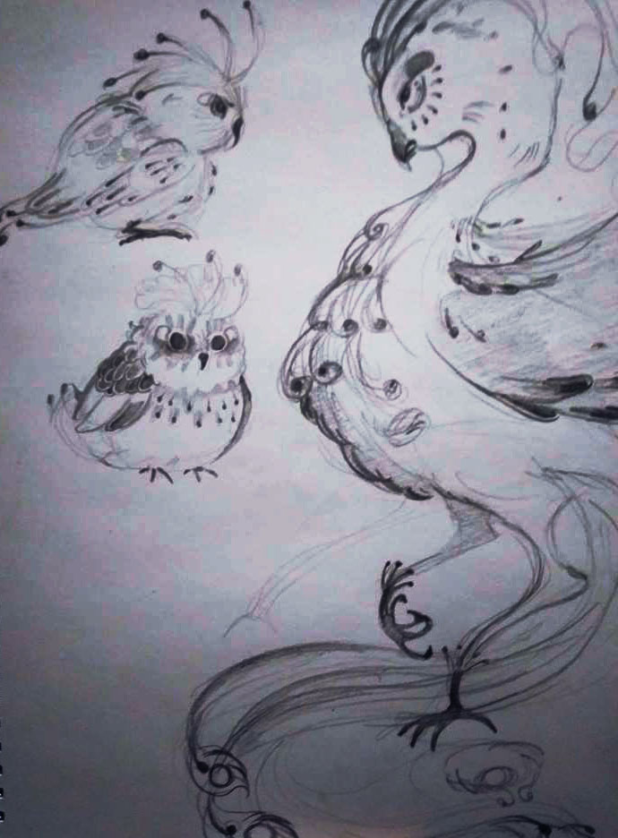

The mother won’t get enough screen time to be fully developed, and really doesn’t need too much at all.  
Obviously she cares for Ciwtylluan and wants him back to their nest.

She’ll be designed as a more elegant and magnificent creature, but should show concern and worry about his whereabouts.

Concept art of the Main Character and his mum By Marta

Assets: -

# The Main Character:

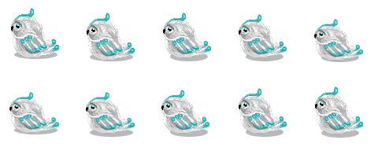

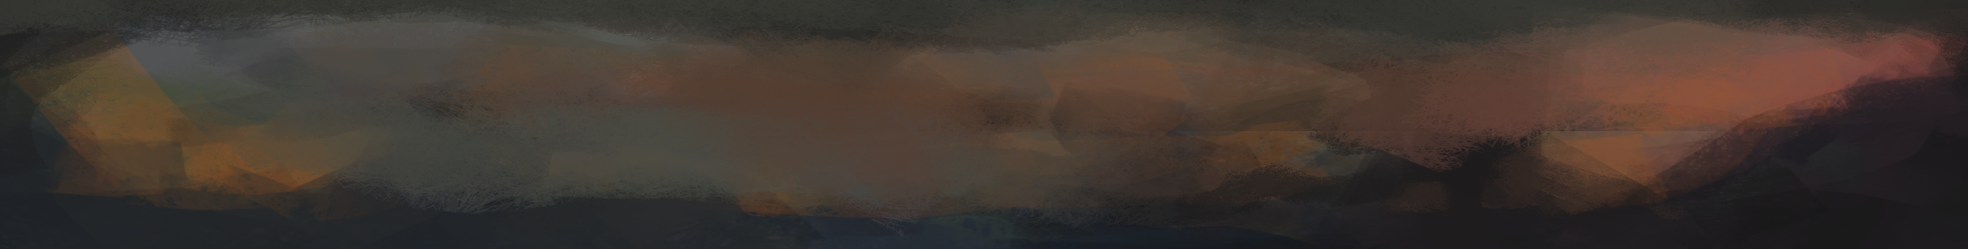Ciwtylluan will have two walk animations spreadsheets, one for  
  
him going left and the other for him going right. We also wish to implement other assets connected to the player character like feathers when he walks as well as a death animation when he   
  
killed by the dangers in the game.

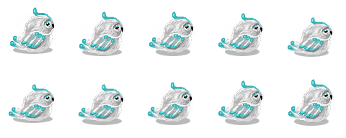

# Dangers:

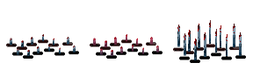

As of current we have one danger which are spikes that will kill ciwtylluan when he collides with them.

# Aids:



There are currently 2 aids in the game, a jump mushroom and a mana potion.

# Tile sets:

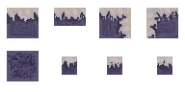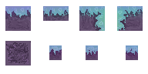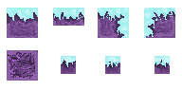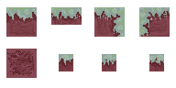

We have 4 tile sets as of yet for the three areas where the game takes place, the cave, the dead lands, and the jungle.

# Décor:

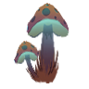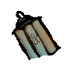

Each level will have its own décor, to give its own unique look.



The first area, the cavern, will contains a variety of unique decorations   
  
like Mushrooms, rocks, spider webs, rocks, roots and old lanterns. These decorations will give the player the impression that this is somewhat   
  
of a normal world. Also Ciwtylluan will standout more.

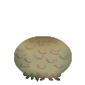

The third area, the jungle will be completely different to   
  
the first as it will contain far more colourful and odd looking plants and give the impression that this world is not normal. The design overall of the Jungle will have somewhat of an oceanic look to it.

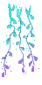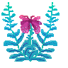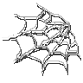

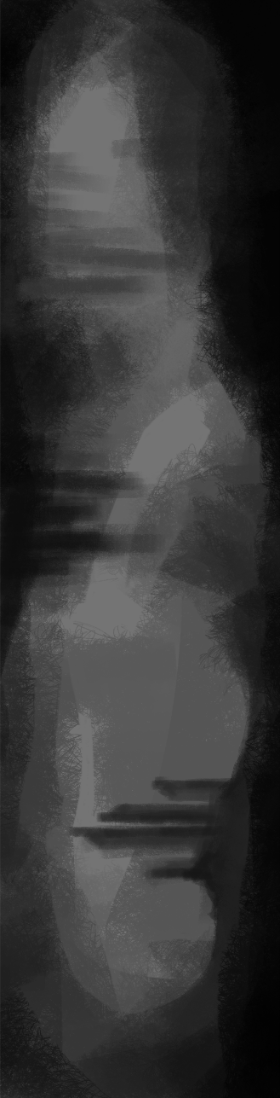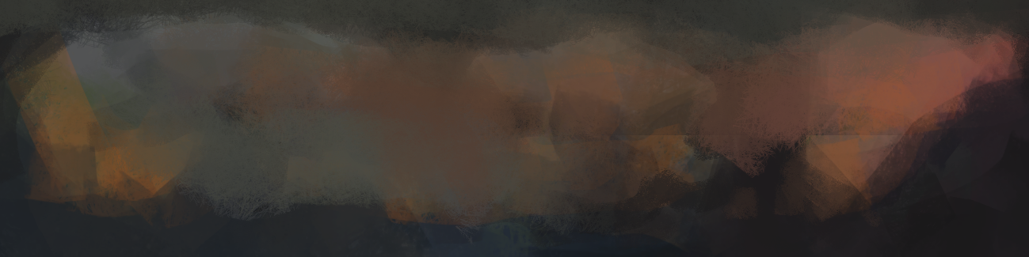Level Design:

The general philosophy of the level design will be easy at the start, and then a gradual   
increase in difficulty and complexity.

The first area is more or less the Tutorial area, which will allow the player to understand the  
mechanics. The look of the first area will also look like a cavern with glowing mushrooms and  
some ancient artefacts.

The First level should be constructed in a way that shows the player the basic main   
mechanics, like Moving blocks, aids and exits. This should give the player a place to   
experiment and get to understand what they’re doing before they progress further.   
Design wise, the level should give indications of what has happened narratively.   
Where the player starts should be an area where there is foliage and a light shining down   
indicating that the source of it is the outside. This should also communicate that where  
Ciwtylluan has come from.

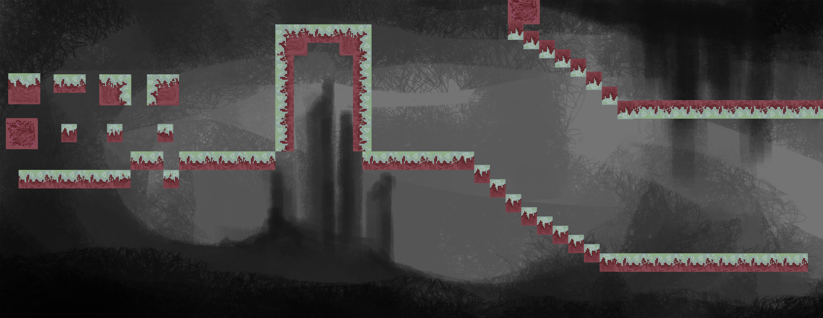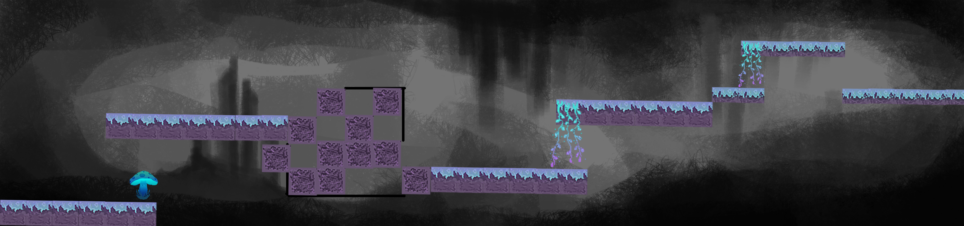

Level 1 Concept designed by Jack

Level 1 concept (above) and Design (below) by Eva

The second level should be a slightly more complex level giving the player more of an   
advanced understanding of mechanics like Mana, and dangers. It should still be constructed  
in a way to challenge the player’s knowledge from the previous level. Unlike the first level, it  
will be darker to indicate that this is deep into the cavern.

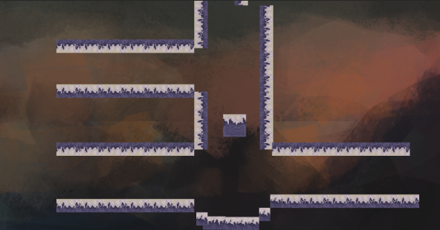

Level 2 design by Eva

Level 2 Concept designed by Jack

The Third level will be the most complex of all the First Area levels. This will be the final level  
of the first area, and it will give the player the most important concept to manage, death and  
failure. The level should be doable, but have a fair amount of challenge through complex  
platforming and a large variety of dangers. Design wise it should indicate this is the final level  
by showing light that indicates that the exit is leading to the outside. But it should be a  
different kind of light that could fool the player into thinking it is the evening, when it actual  
fact it is the dead place.

Level 3 Design by Eva

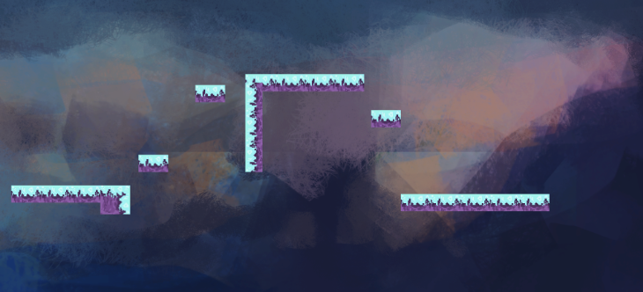

Level 3 Concept designed by Jack



Gameplay: -

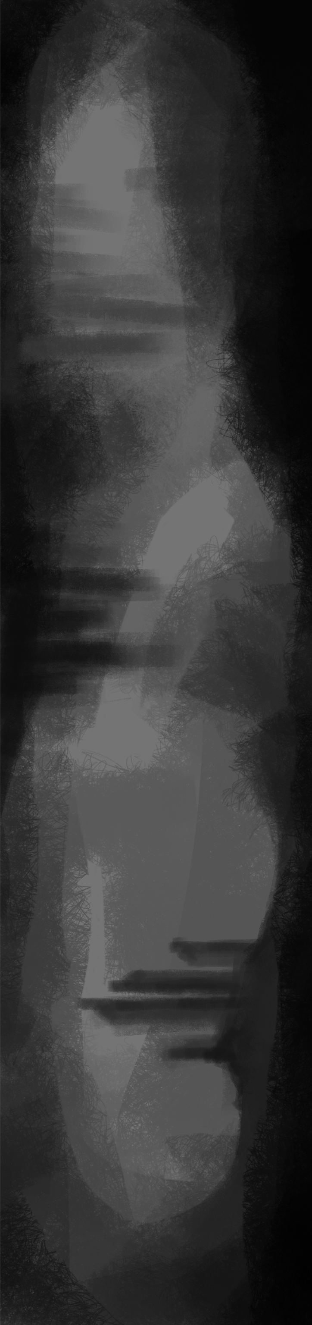

# Main Mechanics:

The main and most essential mechanic to play the game is the control over the landscape of  
the levels. The Player can create paths, and avoid dangers by moving tiles.

# Dangers:

Spikes are currently the main and only danger. When Ciwtylluan collides with them he will be  
killed instantly and burst into a puff of feathers.  
Platforms can also be a danger as they reset which could cause Ciwtylluan to be crushed.  
Other Creatures (in the third area) will be lurking in search food, like Ciwtylluan who would  
make a nice quick snack.

# Aids:

Mushrooms are Aids that cause Ciwtylluan to jump into the air when making contact with   
them. They will sometimes be hidden underneath the ground.

Mana potions are Aids that can increase the player’s Mana. This can give the player more  
options to complete a level.

(Possible) There will be these roots that will be available throughout the entirety of the game  
that will be placed in awkward and hard to reach places. If Ciwtylluan collects all of them the  
player will get the Happy ending where Ciwtylluan doesn’t die.